Bioremediation of strontium and copper in

water by algae

Sun Yudong, Zheng Yu Bo

Hwa Chong Institution (High School)

Mentor: Lena Koh

August 10, 2014

**Abstract**

Heavy metal pollution is a serious problem that the world is facing today. A remarkable increase in the use of heavy metals over the past few decades has inevitably resulted in an increased flux of metallic substances in the aquatic environment. Algae are a large group of photoautotrophic organ-isms. They can survive in various kinds of conditions and are extremely easy to grow and can be readily used for bioremediation. In this experiment, dead and live *Ulva* was exposed to different concentrations of copper and strontium in water. The final concentration of heavy metal ions left in the water was measured after a trial period of five days. Bioremediation capacity and bioremediation efficiency were then calculated. Live *Ulva* was more effective than dead *Ulva* in remediating heavy metal ions.

**1 Introduction**

**Rationale**

With rapid industrialisation, heavy metal pollution is a serious problem that the world is facing today. A remarkable increase in the use of heavy metals over the past few decades has inevitably resulted in an increased flux of metallic substances in the aquatic environment (Bishnoi, Anju, & Garima, 2004).

Metals can pose health hazards if their concentrations exceed allowable limits. Even when the concentration of metals does not exceed these limits, there is still a potential for long-term contamination, since heavy metals are known to be accumulative within biological systems.

One of the heavy metal ions, Cu2+, finds its way to water bodies through wastewater from Copper wire mills, coal burning industries, electroplating, tanning, smelting and refining, insecticides, fungicides, and iron and steel producing industries (Bishnoi, Anju, & Garima, 2004). Cu2+ is also a major component of anti-fouling paint on ship hulls. This has resulted in an increase in Cu2+ levels in the ocean.

Currently, the concentration of copper in seawater ranges from 0.00025 ppm in water to up to 100 ppm in sediments. (Neal Blossom, n.d.) According to US EPA, the acceptable level of copper in drinking water is 1.3 ppm (n.d.). After a nuclear disaster, radioactive isotopes of strontium are often released. The concentrations of 90Sr were found up to 85 Bq m-3 and 265 Bq m-3 for 89Sr after the Fukushima Daiichi incident (Casacuberta et al., 2013). At its maximum, the concentration of strontium in water is 960 ppm, after a nuclear disaster. However, the acceptable level of strontium in drinking water is 13.74 ppm.

Unfortunately, current physico-chemical methods, such as chemical precipitation, are widely used to remove heavy metal ions from wastewater. However, they may be ineffective and expensive, especially when the heavy metal ions are in solutions containing in the order of 1-100 mg dissolved heavy metal ions/L. (Bunghez, Ion, Dumitriu, & Fierascu, 2010).

Research interests into the production of cheaper adsorbents to replace costly conventional methods of wastewater treatment are attracting attention of scientists. Therefore, this project focused on the remediation of non-radioactive Sr2+ and Cu2+ using Ulva Algae, to explore a more economical method of remediation through the use of biomass.

**Literature Review**

Algae are a large group of photoautotrophic organism that can survive in various kinds of conditions and are extremely easy to grow (“Large-Scale Production of Biofuels Made From Algae Poses Sustainability Concerns; Further Innovations Needed to Reach Full Potential,” 2012) Research has shown that freshwater algae *Spirogyra sp.* has the ability to accumulate heavy metals such as Cadmium and Mercury (Kumar & Oommen, 2010). We believe that the same can be achieved with marine green algae under the same division *Chlorophyta*. Research has shown that marine algae *Tetraselmis* is able to remove Cadmium (P´erez-Rama, Abalde Alonso, Herrero L´opez, & Torres Vaamonde, 2002). We speculate that another marine alga *Ulva* will also be able to remove heavy metal ions.

Bioremediation of heavy metal ions could involves two stages, physical adsorption and absorption. Physical adsorption is the process where the heavy metal ions are adsorbed into the algae. According to research, many potential binding sites occur in algal cell walls and alginate matrices for biosorption. The cell walls of green algae contain heteropolysaccharides, which offer carboxyl and sulfate groups for sequestration of heavy metal ions (Kumar & Oommen, 2010). These heavy metal ions could also be absorbed by the algae and assimilated into the algal tissues. According to Bunghez, Ion, Dumitriu and Fierascu (2010), heavy metals such as copper are essential micronutrients for algal metabolism and that the *Mayaca fluviatilis* alga takes in heavy metal ions and absorbs it (2010).

**Objective**

We aim to investigate whether live or dead *Ulva* are better bioremediators. This is done through immersing live and dead *Ulva* in various concentrations of heavy metal ion solutions for five days. The bioremediation capacity and bioremediation efficiency were then calculated to determine which the bioremediator is.

**Hypothesis**

Our hypothesis is that live *Ulva* will have better bioremediation properties than dead *Ulva*, due to them being able to assimilate the heavy metal ions into their tissues after taking them in.

**2 Materials and Methods**

**2.1 Materials and Apparatus**

**Materials**

* Copper(II) Sulfate pentahydrate
* Strontium Chloride hexahydrate
* *Ulva*
* Deionized Water
* Xylenol Orange
* Instant Ocean ®

**Apparatus**

|  |  |
| --- | --- |
| * Centrifuge * Photospectrometer * Tanks * Pumps * Lights * Colorimeter | * Orbital Shaker * See-Saw Rocker * Air Conditioner * Lux Meter * Oven * pH Meter |

**2.2 Methods**

**Variables**

|  |  |
| --- | --- |
| **Independent** | Live of Dead *Ulva*  Initial Concentration of heavy metal ion solution  Type of heavy metal ion (Sr2+ or Cu2+) |
| **Dependent** | Concentration of heavy metal ion solution over time |
| **Controlled** | Mass of *Ulva* used  Volume of water  Temperature of surroundings  Temperature of Solution  Amount of Light available  Time interval between each measurement |

**Cultivation of Algae**

Instant Ocean ® was first purchased from a supplier. Tap water was allowed to sit for 3 – 4 days. Seawater was then prepared by adding Instant Ocean® salt to water until the specific gravity of the solution of 1.026 at R.T.P. was obtained by following the recommended concentration. The solution was then left to circulate with a powerhead (pump) overnight before use. *Ulva* was then obtained and harvested from a local natural habitat and rinsed in ethanol. *Ulva* was then submerged in the seawater solution in the tank at a water temperature of 22°C. The tank was then placed 18 to 24 inch (45.72 cm to 60.96 cm) under 200 to 400 foot candles (2152.78 lux to 4305.56 lux) of florescent light. The culture was then allowed to grow.

**Preparation of Wastewaters with heavy metal ions**

**Preparation of Copper(II) ion solution from Copper(II) Sulfate**

Using calculations, 3 L of stock Copper(II) ion solution was prepared by adding a specific mass of Copper(II) Sulfate pentahydrate salt to deionized water.

Two concentrations of copper were prepared: 1.3 ppm and 25 ppm.

**Preparation of Strontium ion solution from Strontium Chloride**

Using calculations, 3 L of stock Strontium ion solution was prepared by adding a specific mass of Strontium Chloride hexahydrate salt to deionized water.

Two concentrations of strontium were prepared: 13.74 ppm and 960 ppm.

**Measurement of concentration of strontium**

**Obtaining a Standard Curve**

First, the spectophotrometer was set to 570nm on absorbance. Then a 0.05% w/v xylenol orange solution was prepared by adding 0.765g of SrCl2.6H2O to 250mL of de-ionized water to create a 100ppm solution. A serial dilution was then carried out to obtain a 50ppm, a 25ppm, and a 12.5ppm solution. One cuvette was then filled with distilled water, cleaned with a Kim wipe, and the absorbance was set to zero as a blank. 2mL of the xylenol orange solution and 2mL of the strontium test solution was then placed into another cuvette. Wiping with a Kim wipe, run the solution through the spectrophotometer, and record absorbance. The test was then repeated with each concentration of strontium test solution, running a blank and re-calibrating to zero after each spectrophotometer use. A standard curve was then created by plotting the absorbance (au) of the test solution over the concentration of the strontium solution (ppm).

**Determination of fresh mass to dry mass ratio in live algae**

10 grams (fresh mass) of live algae was retrieved and measured from the growth tank after draining water from the sample using a sieve. The algae were then dried in an oven until no further significant change in mass. The dry mass of the sample was then measured. The ratio of fresh mass to dry mass was then calculated. This was repeated 3 times and the average of the ratios was then calculated.

**Bioremediation test using living algae**

In order to investigate the efficiency of using live algae as a bioremediator, live algae was taken and submerged in a 1% dry mass to volume ratio heavy metal solution. Since it is impossible to measure the dry mass of algae without killing it, the dry mass to fresh mass ratio was used, as mentioned above, and the dry mass from the fresh mass of the algae was calculated. Next, solutions of algae were placed in conical flasks, and heavy metal solutions of varying concentration will be added to these flasks. The flasks were then placed on an orbital shaker at 120 revolutions per minute to ensure that the algae were properly mixed.

|  |  |
| --- | --- |
| Sr2+ | Cu2+ |
| Minimum concentration: 13.74 ppm  (Human threshold for drinking water) | Minimum concentration: 1.3 ppm  (Human threshold for drinking water) |
| Maximum concentration: 960 ppm  (In situations such as nuclear disasters) | Maximum concentration: 25 ppm  (Beyond which it becomes extremely toxic for organisms such as sea urchins) |

For both heavy metal ions, the control was deionized water.

The colorimeter was used to test for the final Cu2+ concentration, with necessary dilutions, and spectrophotometer to test for final Sr2+ concentration, also with necessary dilutions. Readings were taken on the fifth day of each trial. We also found the final concentration of heavy metals in the algae, assuming that any drop in heavy metal concentration was resultant of algae bioremediation. To do this, a sample from each of the conical flasks was taken, and centrifuged, and then the supernatant was tested. The biosorption capacity and biosorption efficiency was then calculated with the following formulae:

$$q=\frac{v (C_{i}-C)}{m}$$

where:

$$q=biosorption capacity \left(mg g^{-1}\right) \\ v=volume of solution \left(ml\right) \\ C_{i}=inital concentration of solution \left(mg g^{-1}\right) \\ C=final concentration of solution \left(mg g^{-1}\right) \\ m=biomass (g)$$

$$e=\frac{100(C_{i}-C)}{C_{i}}$$

where:

$$e=biosorption efficiency \left(\%\right) \\ C_{i}=inital concentration of solution \left(mg g^{-1}\right) \\ C=final concentration of solution \left(mg g^{-1}\right)$$

**Bioremediation test using dead algae**

For this test, the procedure was similar to the test with live algae, except that the live algae was dried in an oven at 70°C until no further change in dry mass before conducting the test. All other variables were kept constant. However, the test was conducted in centrifuge tubes and placed on a see-saw rocker at 30 revolutions per minutes throughout the experiment to ensure that the algae were properly mixed.

**Comparison of results**

In order to determine the best bioremediator, 30 readings for live and dead algae in the different concentrations were obtained, after which the biosorption capacity and efficiency for both live and dead algae was calculated and compared. A comparison between both types of heavy metal ions were then carried out. In order to verify whether the difference between the efficiency and the capacity of the samples were statistically significant, a two-sample T-test was used to obtain the p-value.

**3 Results**

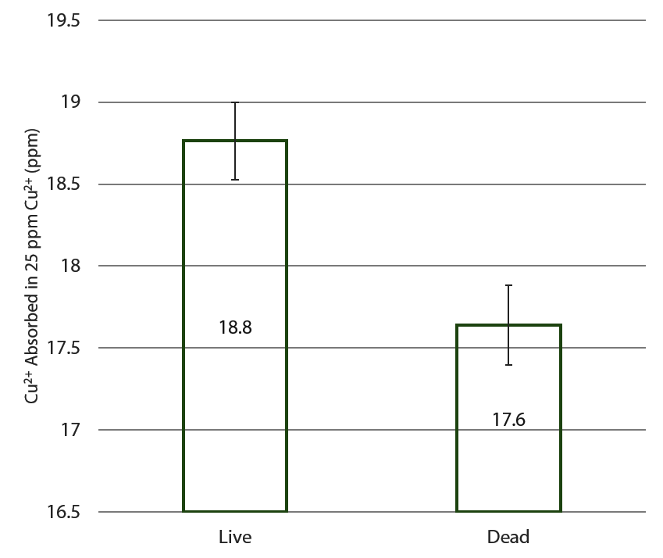

Figure 2: Graph showing the effect of aliveness of *Ulva* on the concentration of Copper(II) ions absorbed by *Ulva* in 25 ppm Copper(II) solution after 5 days

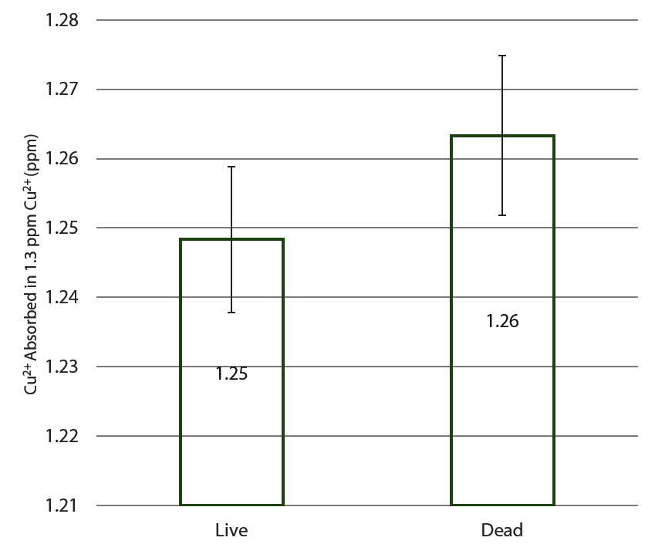

Figure 1: Graph showing the effect of aliveness of *Ulva* on the concentration of Copper(II) ions absorbed by *Ulva* in 1.3 ppm Copper(II) solution after 5 days

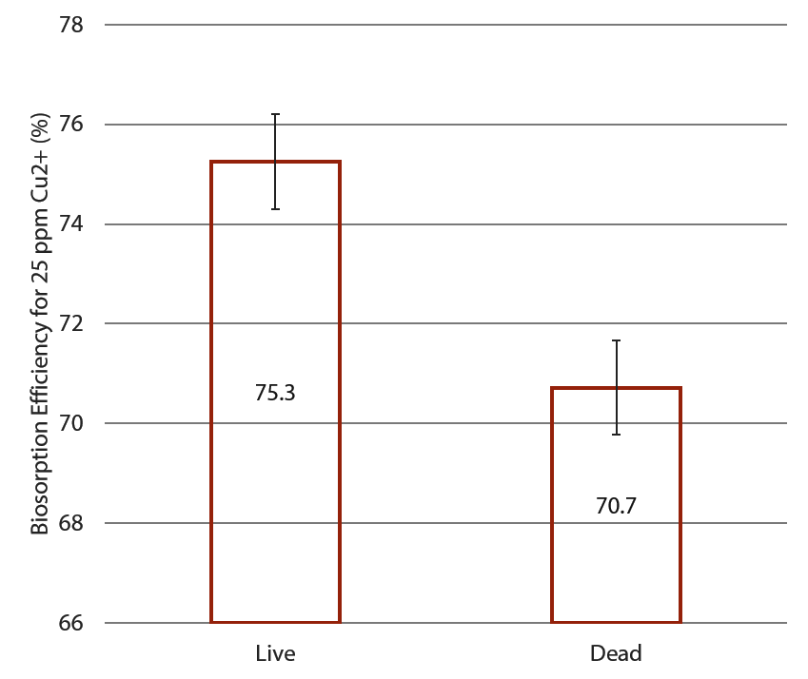

Figure 4: Graph showing the effect of aliveness of *Ulva* on the Biosorption Efficiency of *Ulva* in 25 ppm Copper(II) solution

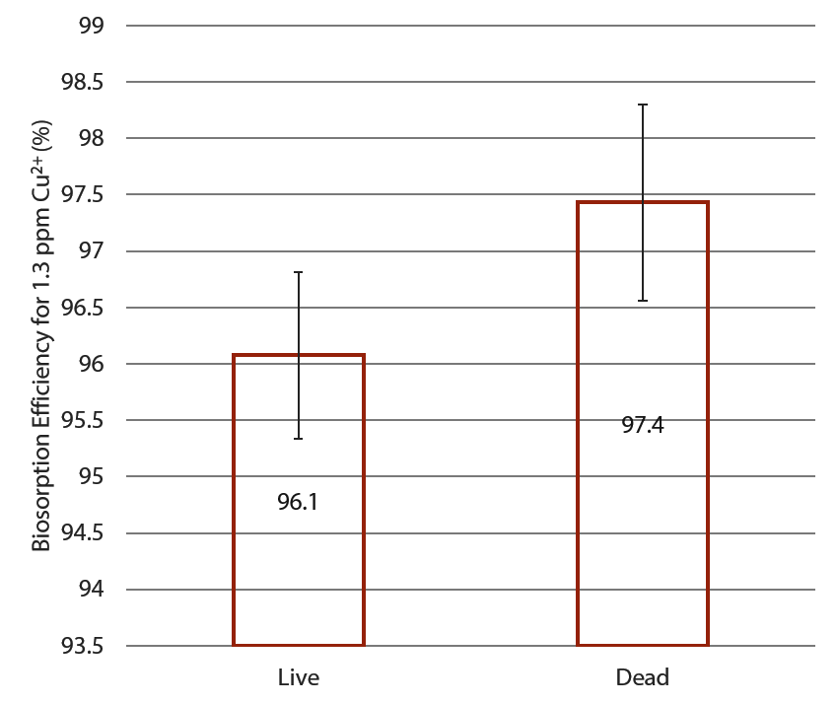

Figure 3: Graph showing the effect of aliveness of *Ulva* on the Biosorption Efficiency of *Ulva* in 1.3 ppm Copper(II) solution

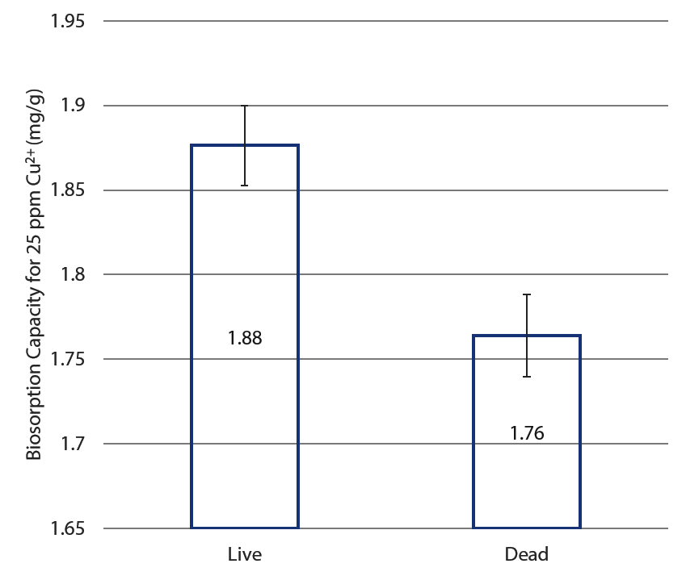

Figure 6: Graph showing the effect of aliveness of *Ulva* on the Biosorption Capacity of *Ulva* in 25 ppm Copper(II) solution

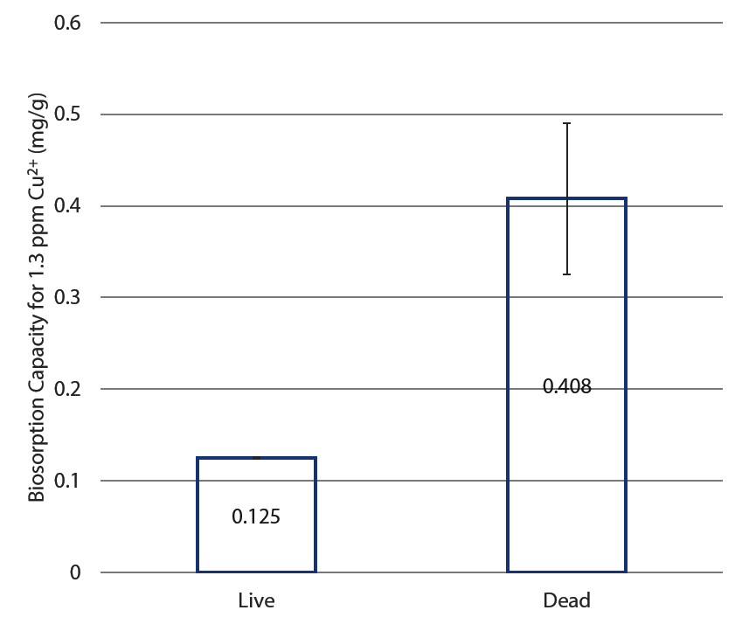

Figure 5: Graph showing the effect of aliveness of *Ulva* on the Biosorption Capacity of *Ulva* in 1.3 ppm Copper(II) solution

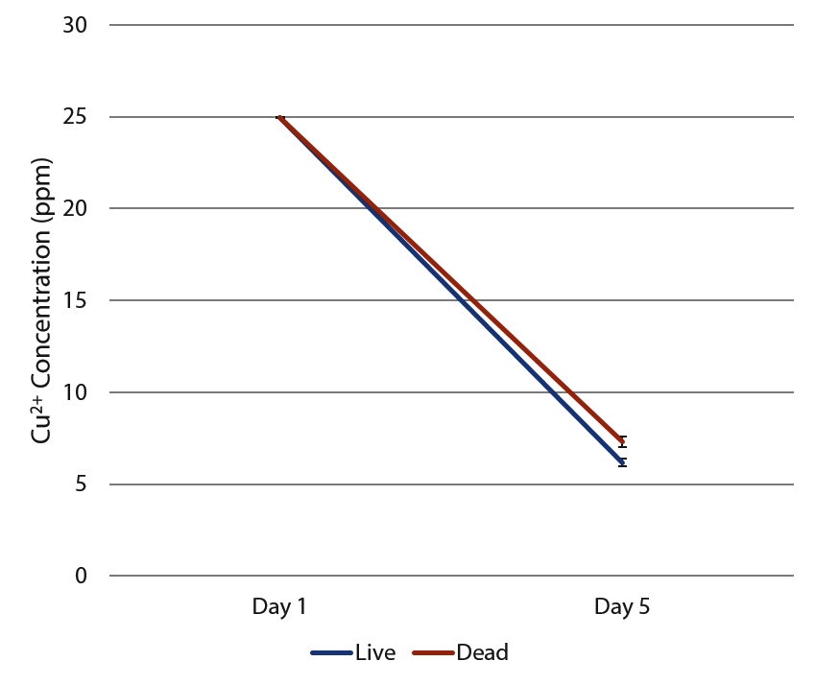

Figure 8: Graph showing concentration Copper(II) ions in 25 ppm Copper(II) solution over time

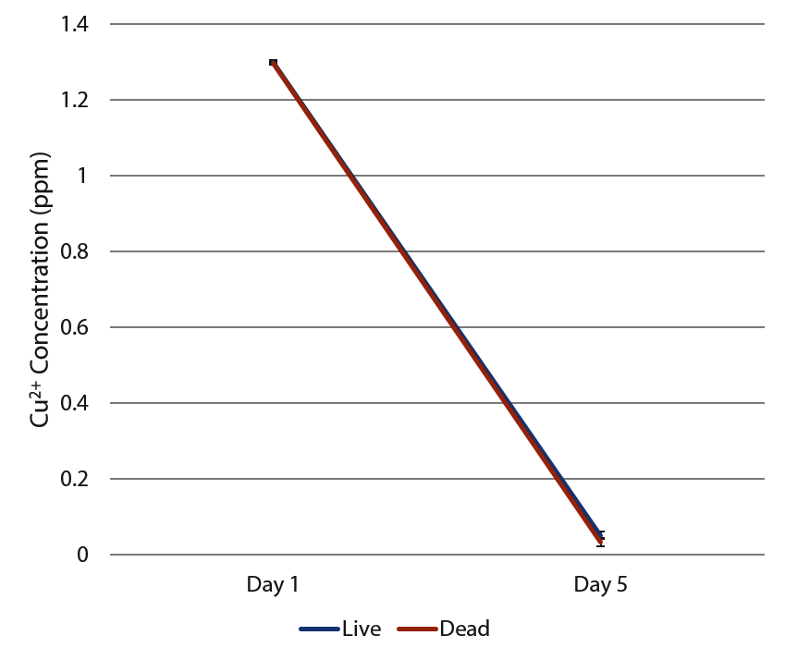

Figure 7: Graph showing concentration Copper(II) ions in 1.3 ppm Copper(II) solution over time

**4 Discussion**

From the results we have obtained, we realised that the live algae performed better than the dead and harvested algae when it comes to the bioremediation of Copper(II) ions. As shown from our results, the live algae had a significantly higher biosorption efficiencies and capacity as compared to the dead algae. For those in which the dead performed better, a t-test was conducted and the p-value of more than 0.05 suggested that the results were insignificant. From Figures 7 and 8, it was also observed that at higher concentrations, there was a much more of a significant difference between the dead and alive. This could be because of the saturation of binding sites on the algal membranes in the dead algae samples.

Since the live algae was able to bioremediate Cu2+ ions better than dead algae, the improved results was most likely due to the mechanism of uptake that is solely available in live algae and not dead algae, which is the ability to take in the heavy metal ions and assimilate them into the organism tissues.

**Limitations**

For strontium, the results were inconclusive as the xylenol indicator presented too much fluctuation and the results were hence unable to be used for determination of whether the live or the dead and harvested algae was better. The fluctuation could be due to factors such as temperature and relatively high concentrations of strontium, however, even after the con centration of strontium solution was lowered, no correlation was found and hence it was not possible to reliably and consistently extrapolate the data. In fact, the standard deviation was as much as 14 ppm for the live algae tests. Until a more suitable indicator is found, results for strontium remain difficult to obtain.

After drawing out solutions for testing, the amount of solution left in was reduced, thereby increasing algae-to-solution ratio, which may affect the results obtained.

The dry mass to wet mass ratio may vary for every algal tissue, hence the average obtained may not be accurate, hence there could be more, or less algal tissue used for bioremediation in the tests conducted, and more accurate tests could be conducted, if possible.

**Future Work**

With such results, products such as a bioreactor could be developed with algae at cheap cost, especially if eutrophication has resulted in abundant growth of algae in certain areas. Currently a prototype has been developed by putting powdered algae in teabags and placing them in a structure made using recycled plastic bottles. (Figure 9) In the middle layer, algae is concentrated to increase remediation properties. The middle piece also contains small holes to allow sufficient time for the algae in the center to remediate the heavy metal ions. This was made just as a proof of concept. Extensively testing and developing the prototype could take much more time.

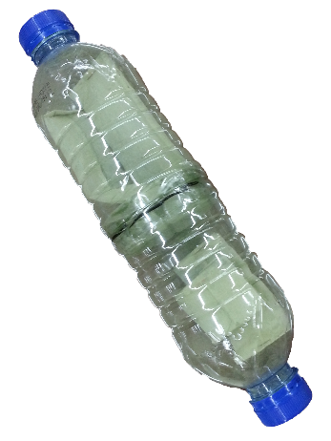

Figure 9: Current Prototype for Bioreactor

Beyond this project, bioremediation remains an avenue for exploration in reducing human impacts on the environment.

This study could be repeated with other varying concentrations of Cu2+ and expanded to other heavy metal ions such as Zn2+ or Pb2+. Other species and genus of algae such as *Sargassum*, including other marine organisms could also be used.

**5 Conclusion**

In conclusion, from the results obtained, the live algae outperformed and were a better bioremediator than the dead and harvested algae and were able to remediate 6% more Cu2+ ions at a moderate level of 25 ppm. From there, a prototype for a bioremediator was developed, through which we can pass water and remove the heavy metal ions within. However, more work could be done to determine the suitability of using algae to bioremediate other substances, including other heavy metal ions.

**References**

Bielmyer, G. K., Brix, K. V., Capo, T. R., & Grosell, M. (2005). The effects of metals on embryo-larval and adult life stages of the sea urchin, Diadema antillarum. *Aquatic toxicology (Amsterdam, Netherlands)*, *74*(3), 254–263. doi:10.1016/j.aquatox.2005.05.016

*Bioconcentration factors (BCFs) for aquatic organisms*. (n.d.). Retrieved from http://uwrl.usu.edu/www/doucette/6730/CEE%205730%20BCF%20lec%209-1.pdf

Bishnoi, N. R., Anju, P., & Garima. (2004). Biosorption of copper from aqueous solution using algal biomass. *Journal of Scientific & Industrial Research*, *63*(October 2004), 813–816.

Bunghez, I.-R., Ion, R.-M., Dumitriu, I., & Fierascu, R.-C. (2010). Heavy Metal Ions Depollution by Marine Natural Products. *Journal of Science and Arts*, *1*(12), 73–78.

Casacuberta, N., Masque, P., Garcia-Orellana, J., Garcia-Tenorio, R., & Buesseler, K. O. (2013). 90Sr and 89Sr in seawater oﬀ Japan as a consequence of the Fukushima Dai-ichi nuclear accident. *Biogeosciences*, *10*, 3649–3659. doi:10.5194/bg-10-3649-2013

Fu, Y. Q., Li, S., Zhu, H. Y., Jiang, R., & Yin, L. F. (2012). Biosorption of copper from aqueous solutions by mycelial pellets of rhizopus oryzae. *African Journal of Biotechnology*, *11*(6), 1403–1411.

Kumar, J. I. N., & Oommen, C. (2010). Removal of heavy metals by biosorption using freshwater alga Spirogyra hyalina. *Journal of Environmental Biology*, (January 2012), 27 – 31.

Large-Scale Production of Biofuels Made From Algae Poses Sustainability Concerns; Further Innovations Needed to Reach Full Potential. (2012, October 24). *National-Academies.org | Newsroom*. Retrieved November 9, 2013, from http://www8.nationalacademies.org/onpinews/newsitem.aspx?RecordID=13437

Mehta, S. K., & Gaur, J. P. (2005). Use of algae for removing heavy metal ions from wastewater: progress and prospects. *Critical reviews in biotechnology*, *25*(3), 113–152. doi:10.1080/07388550500248571

Neal Blossom. (n.d.). Copper in the Ocean Environment.

Pérez-Rama, M., Abalde Alonso, J., Herrero López, C., & Torres Vaamonde, E. (2002). Cadmium removal by living cells of the marine microalga Tetraselmis suecica. *Bioresource Technology*, *84*(3), 265–270. doi:10.1016/S0960-8524(02)00045-7

Suresh, B., & Ravishankar, G. A. (2004). Phytoremediation--a novel and promising approach for environmental clean-up. *Critical reviews in biotechnology*, *24*(2-3), 97–124. doi:10.1080/07388550490493627

US EPA, O. (n.d.). Basic Information about Copper in Drinking Water. Retrieved November 15, 2013, from http://water.epa.gov/drink/contaminants/basicinformation/copper.cfm